**University of engineering & technology Peshawar**



**Circuit & system-1**

**Lab report # 14**

**Fall 2020**

**Submitted by: Ashfaq Ahmad**

**Section: B**

**Reg No: 19PWCSE1795**

**Semester: 2nd**

**Student signature: ____________________**

**Submitted to:**

**Eng: faizullah**

**Department Of Computer System Engineering**

**ASSESSMENT RUBRICS LAB # 14**

**Analyzing RC-Circuit using PSpice**

|  |  |  |
| --- | --- | --- |
| **Criteria** | **Excellent** | **Marks Obtained** |
| 1. **Objectives of Lab** | All objectives of lab are properly covered  [Marks 0.5] |  |
| 1. **RC-Circuit** | Brief introduction of RC-Circuit  [Marks 1] |  |
| 1. **PSpice** | Brief introduction about PSpice  [Marks 0.5] |  |
| 1. **Circuit Diagram** | Circuit diagram of RC circuit with proper labeling  [Marks 1] |  |
| 1. **Procedure of PSpice,**   **Graph** | PSpice procedure and steps followed for RC-Circuit settings and to get graph. Simulated graph results are also shown  [Marks 6] |  |
| 1. **Conclusion** | Conclusion about RC-Circuit analysis  [Marks 1] |  |

1. **Objective of lab:**

* First of all to know about RC-circuit.
* To know more about pspice.
* To know about analyzing of RC-circuit using pspice.

1. **Introduction to RC-circuit:**

* A **resistor–capacitor circuit** (**RC circuit**), or **RC filter** or **RC network**, is an electrical circuit composed of resister and capacitor driven by voltage or current source.
* A first order RC circuit is composed of one resistor and one capacitor and is the simplest type of RC circuit.
* RC circuits can be used to filter a signal by blocking certain frequencies and passing others.

Given figure (a) shows a simple  RC-circuit that employs a dc (direct current) voltage source , a resistor  a capacitor and a two-position switch. The circuit allows the capacitor to be charged or discharged, depending on the position of the switch. When the switch is moved to position A  the capacitor charges, resulting in the circuit in part (b). When the switch is moved to position B, the capacitor discharges through the resistor.

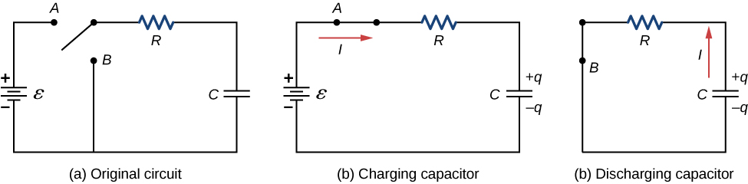

1. *An RC-circuit with a two-pole switch that can be used to charge and discharge a capacitor.*
2. *When the switch is moved to position A the circuit reduces to a simple series connection of the voltage source, the resistor, the capacitor, and the switch.*
3. *When the switch is moved to position B  the circuit reduces to a simple series connection of the resistor, the capacitor, and the switch. The voltage source is removed from the circuit.*
4. **Pspice:**

* SPICE (Simulation Program with Integrated Circuit Emphasis) is a general purpose, open source analog electronic circuit simulator.
* It is a program used in integrated circuit and board-level design to check the integrity of circuit designs and to predict circuit behavior.
* PSPICE is a computer-aided simulation program that enables you to design a circuit and then simulate the design on a computer .
* As this is one of its main purposes, it is used extensively by electronic design engineers for building a circuit and then testing out how that circuit will simulate.
* PSPICE stands for Program Simulation with Integrated Circuit Emphasis.The Electronics Research Laboratory of the University of California developed it and made it available to the public in 1975.
* PSPICE is largely popular because of its user-friendly interface, extensions that support modeling of digital circuits, and its no-cost basic version.
* PSPICE is a general purpose program designed for a wide range of circuit simulation including the simulation of nonlinear circuits, transmission lines, noise and distortion, digital circuits, mixed digital and analog circuits. It can perform dc analysis, steady-state sinusoidal (AC) analysis, transient analysis, and Fourier series analysis.

1. **Procedure of pspice graph:**

* Open schematic program of PSPICE.
* Click on the “Get New Part” button on the toolbar.
* Type ‘r’ in the search bar and place the resistors on the white sheet.
* Type ‘vdc’ in the search bar and place it on the white sheet.
* Type ‘c’ in the search bar for capacitor and place it on the white sheet.
* Type ‘switch’ in the search bar for switch (tclose=0) and place it on the white sheet.
* Type ‘gnd-earth’ and place it on the white sheet.
* Now arrange these components on the white sheet according to the circuit diagram as following.

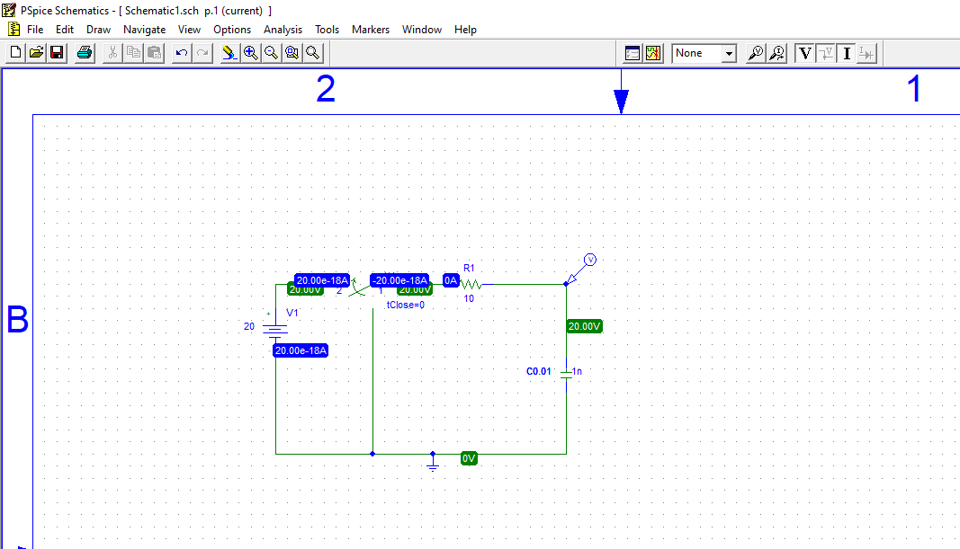

* Click voltage/level Marker button and place on the specified position in the circuit.
* Now click Setup Analysis button.
* A window will open check the transient box and then click on the transient button.
* Set the Print step and final time to a suitable values.
* Check the ‘skip initial transient solution’ box.
* Click OK.
* Now simulate the circuit by clicking the simulate button.
* A graph will appear which will show the operation of your circuit. You can add more curves to your graph by clicking on Add trace button.

**Graph of circuit:**

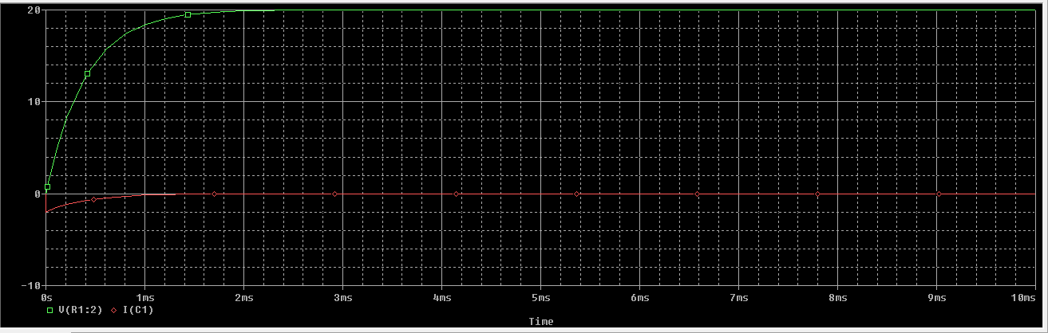

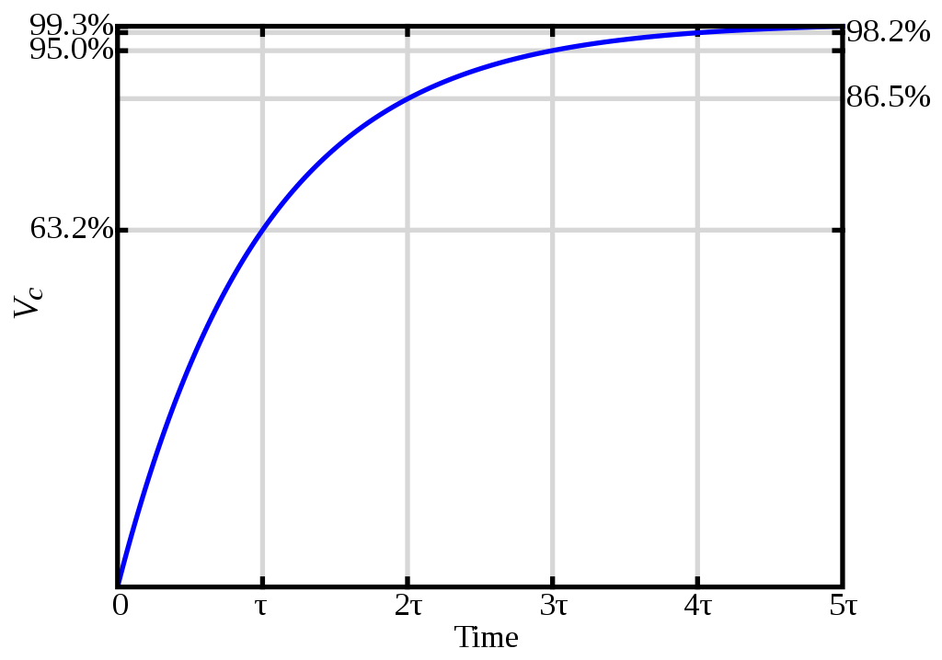

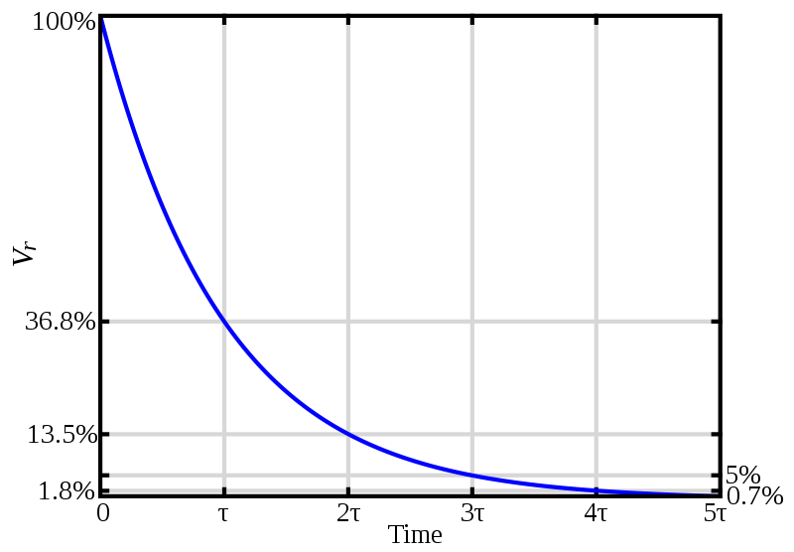

1. **Conclusion:**

In this experiment, charging and discharging of the capacitor with different resistors were observed. The main goal was to charge up the capacitor. For this, the circuit that we used included the resistor and the capacitor with the power supply. To extend the charging process, the resistors were used. In result, we saw that as capacitor was being charged we saw an increase in the voltage, the curve increasing in the graphs above represents that. One time constant represents the time it requires the **voltage** of the **capacitor** to reach 63% of its maximum **voltage**. As time constant increase, the **voltage** reaches the maximum **voltage** of the **capacitor**.

Thus, the increasing phase represents charging of the capacitor and decay represents the discharging.

**THE END**